Punta Tiburón
Address: Lote 6 Condominio Marina VII, Fracc. Punta Tiburón Alvarado, Ver.

Sale Price: $ 4,500,000.00
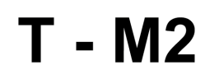
Price per m2. $ 4,118.35
M2 Land: 1,092.67 Ha.
Folio: TV-1427

General Description

Land located at the entrance of the circuit, in front of the guard house, in front of the golf course and the lagoon.

