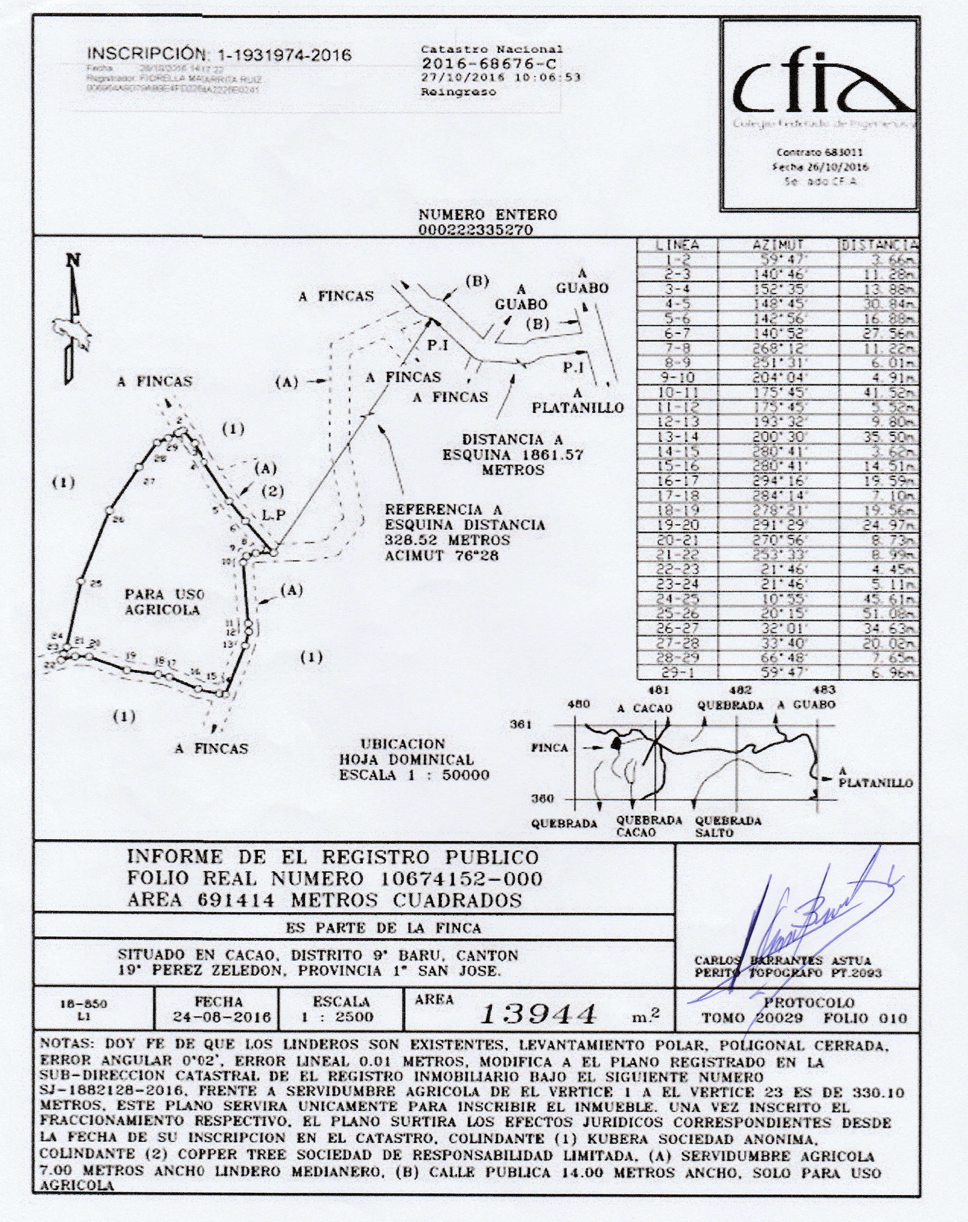
JUDITH GLOE KEITH, US citizen, passport number 549083418, owner of one hundred percent (100%) of the Stock Capital of LA SANACION COMPASIVA LIMITADA a Costa Rican company with identification number 3-102-756819

