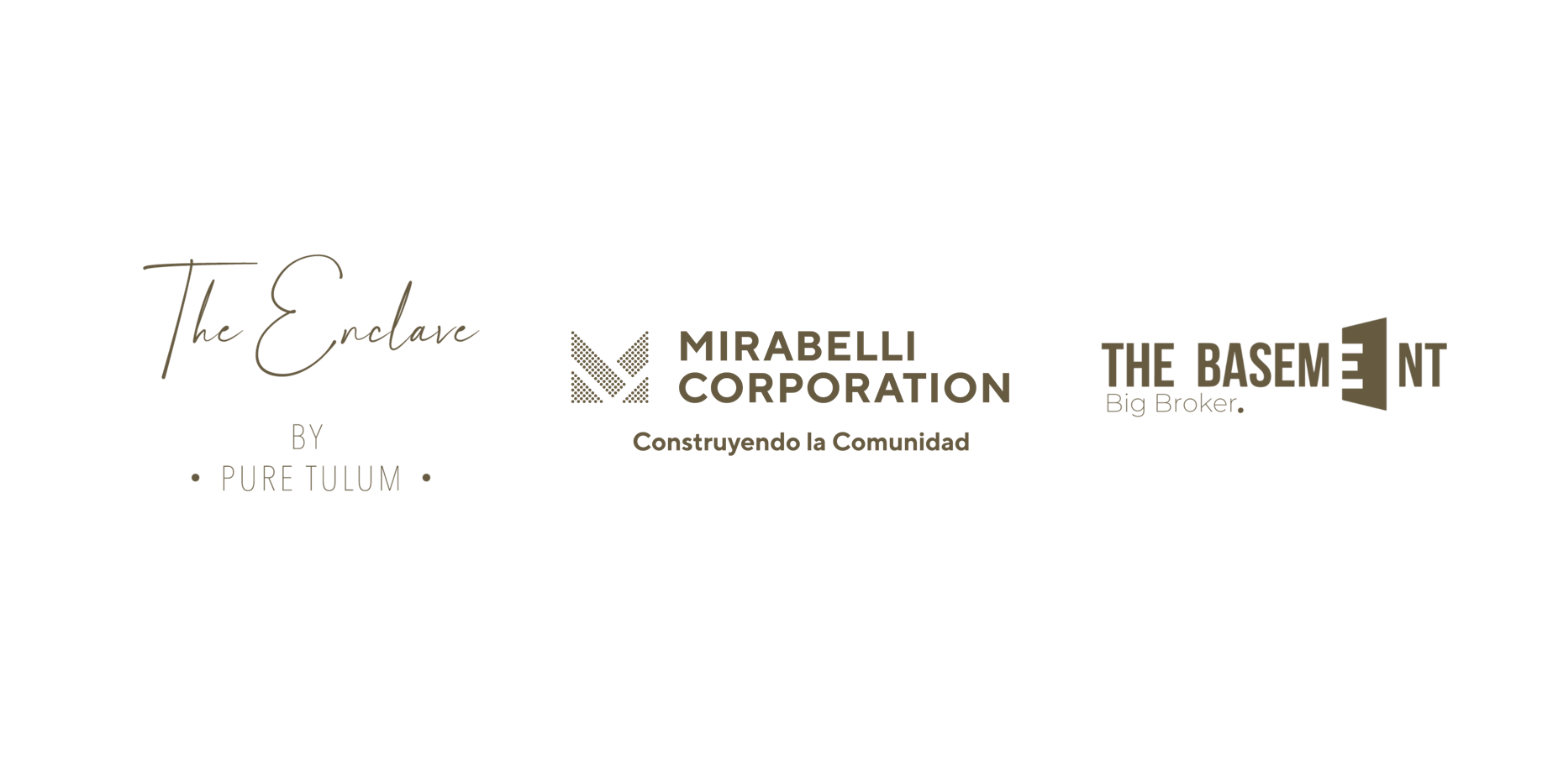

|  |  |
| --- | --- |
| Date: | 23 de mayo de 2022 |

**OFFER TO PURCHASE**

|  |  |  |  |  |
| --- | --- | --- | --- | --- |
| **BUYER INFORMATION** | | | | |
| Legal name: | Kelly Kotler | | | |
| Nationality: | American | | | |
| Birthdate: | 23/07/1986 | | | |
| Place of birth: | Texas | | | |
| Legal name: | Kelly Kotler | | | |
| Occupation: | Entrepreneur | | | |
| Email: | KL90@gmail.com | | | |
| Phone: | 123456 | | | |
| Address: |  | Zip code: | State: | Country: |

|  |  |  |  |  |  |  |
| --- | --- | --- | --- | --- | --- | --- |
| **PROPERTY FEATURES** | | | | | | |
| Development: | The Enclave | | | | | |
| Typology- Lot: | Ahau - 1 | | | | | |
| Lock off: | Yes | X | | No | |  |
| Square Meters: | 313.27 m2 | | | | | |
| Unit Price: | $669,000 USD | | Lock Off price: | | $129,000 USD | |

|  |  |  |  |  |
| --- | --- | --- | --- | --- |
| **OFFER** | | | | |
| Total amount: | $798,000 USD | | | |
| Payment Scheme: | 30%-20%-50% | | | |
| Currency: | MXN |  | USD | X |
| Payment method: | Wire transfer / Cash | | | |

|  |  |  |  |  |  |  |  |  |
| --- | --- | --- | --- | --- | --- | --- | --- | --- |
| **PAYMENT PLAN** | | | | | | | | |
| Down payment: | 30% | X | 50% |  | 80% |  | Other |  |
| Reservation: | $ 5,000 USD | | | | | | | |
| Signature of the contract: | $234,400 USD | | | | | | | |
| Total Down Payment: | $239,400 USD | | | | | | | |

|  |  |  |  |  |  |  |
| --- | --- | --- | --- | --- | --- | --- |
| During construction: | 20% | X | Other | |  | |
| Number of Deferred Payments: | 5 payments | | | Payments Date: | | 30-sep-22 / 30-oct-22/ 30-nov-22/  30-dic-22/ 30-ene-23 | |
| Deferred Payment: | $31,920 USD | | | | | | |
| Total Deferred Payments: | $159,600 USD | | | | | | |

|  |  |  |  |  |  |  |
| --- | --- | --- | --- | --- | --- | --- |
| Delivery: | 50% | X | 20% |  | Other |  |
| Final payment: | $399,000 USD | | | | | | |

|  |  |
| --- | --- |
| Comments: |  |

|  |  |  |
| --- | --- | --- |
|  |  |  |
| Customer | Legal Representative | Sales Advisor |