WhatsApp: https://goo.gl/maps/dddi63SCd23C8woS7

https://www.google.com.mx/maps/dir/Zona+Centro,+36000+Guanajuato,+Gto./San+Jos%C3%BA+de+Cervera,+Gto./@20.9947687,-101.2899991,7260m/data=!3m1!1e3!4m14!4m13!1m5!1m1!1s0x842b74061a0d56e7:0x48eb06ac0f39a47!2m2!1d-101.2566302!2d21.0180008!1m5!1m1!1s0x842b765a23f199c9:0xd394ebc460875bf8!2m2!1d-101.3025!2d20.9677777!3e0

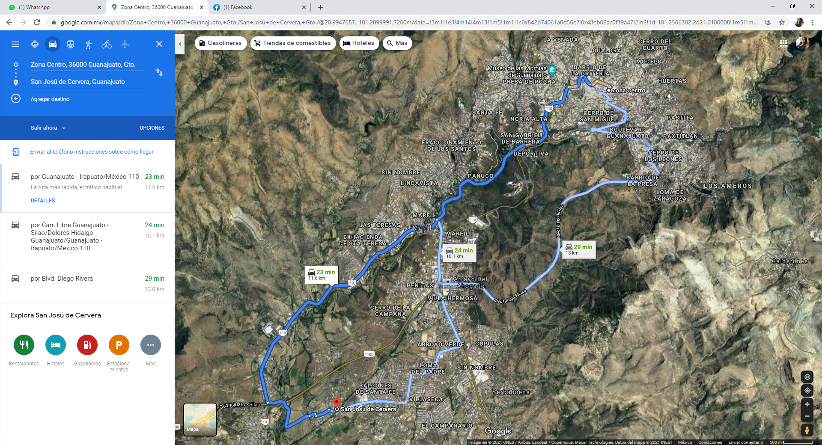
…

whatsApp: https://goo.gl/maps/wbXEUa8uUoZPqNu66

https://www.google.com.mx/maps/dir/Zona+Centro,+36000+Guanajuato,+Gto./San+Jos%C3%BA+de+Cervera,+Gto./@20.9935981,-101.2869235,14.25z/data=!4m14!4m13!1m5!1m1!1s0x842b74061a0d56e7:0x48eb06ac0f39a47!2m2!1d-101.2566302!2d21.0180008!1m5!1m1!1s0x842b765a23f199c9:0xd394ebc460875bf8!2m2!1d-101.3025!2d20.9677777!3e0

