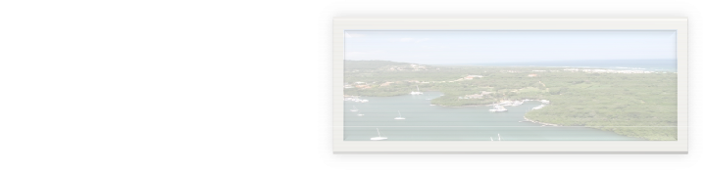
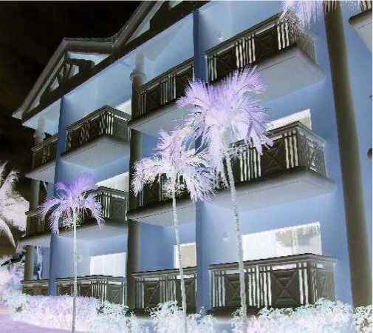
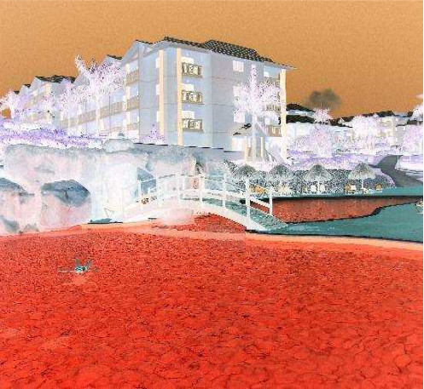
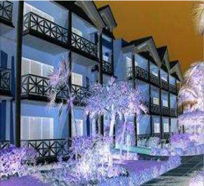
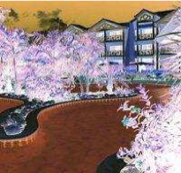
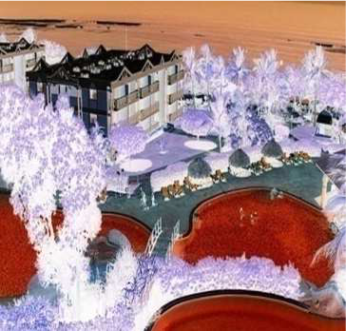
The resort hotel is located in the Puerto Plata area within a land of 120.000m2 with 600m of private beach. 662 Apartment Residential Buildings, distributed in 23 buildings and public areas all on the front line of the beach, with high-level standards, a spectacular panoramic view and on one of the most beautiful beaches of the Caribbean.
The resort hotel, which is not operating at the
moment, is the property of a financial group who wants to sell it.
DOMINICAN REPUBLIC PROJECT Characteristics:
23 Residential and 7 commercial buildings, services and public areas all on the front line of the beach, for a total of 52,000m2 built 2 lobbies
- - - - - - -
7 bars and restaurants 1 amphitheater 2 supermarkets 4 swimming pools
4 tennis courts etc.
It can be sold to an investor who would like, after some works, to run it as a hotel. Another option could be that the future investor turn it into an hotel managed as a “Condo Hotel”, doing reformation and upgrade works to obtain a certain number of flats or suites that could be sold after to particulars or private investors.

